Test Case: tc003_SPX_Dev5_Validar_Funcionalidad_Botones_Add_Remove_Administrador_Roles_Menu
Step 1 - Enter username and password and click to button Enter : Credentials Entered
Image file-name: QC_Testing-runTestMultipleTimes-nov. 20 2025, 02 39 41 p. m.

Image file-name: QC_Testing-runTestMultipleTimes-nov. 20 2025, 02 39 42 p. m.

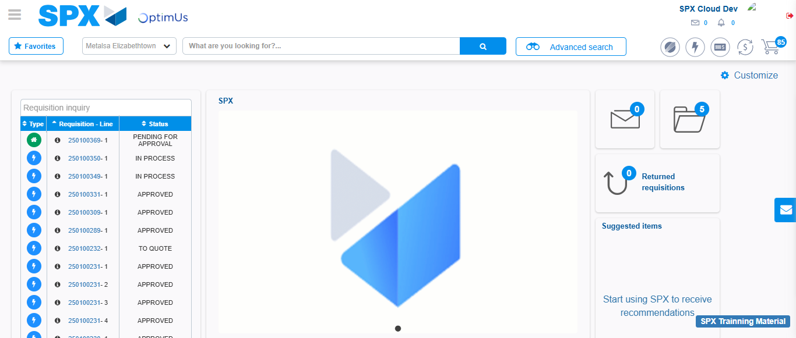Image file-name: QC_Testing-tc001_SPX_Dev5_Validar_Filtro_Campo_MenuName_Administrador_Roles_Menu-nov. 20 2025, 02 40 13 p. m.

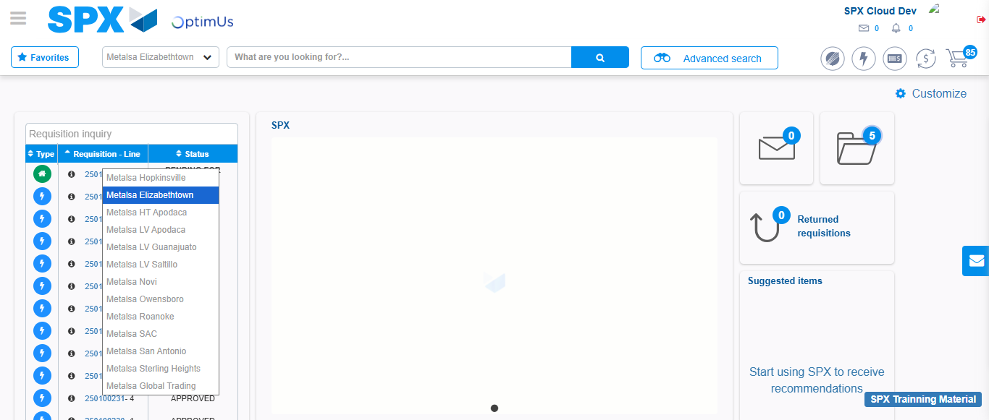Image file-name: QC_Testing-tc002_SPX_Dev5_Validar_Filtro_Campo_URLPath_Administrador_Roles_Menu-nov. 20 2025, 02 40 36 p. m.

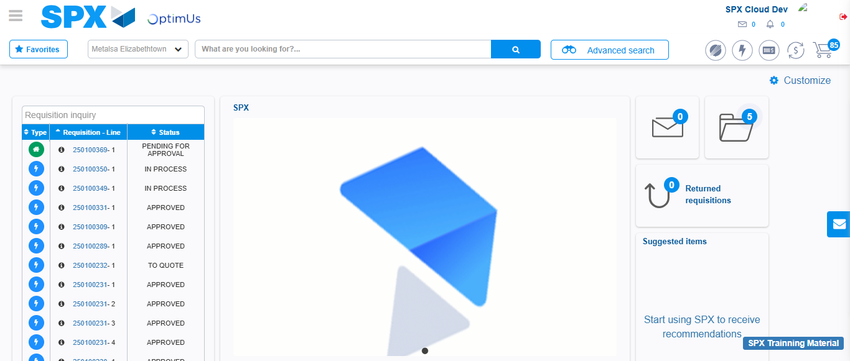Image file-name: QC_Testing-tc003_SPX_Dev5_Validar_Funcionalidad_Botones_Add_Remove_Administrador_Roles_Menu-nov. 20 2025, 02 41 01 p. m.

Step 2 - Select to UEN and Access to Administrador Roles Menu: UEN Correctly selected and Correct access
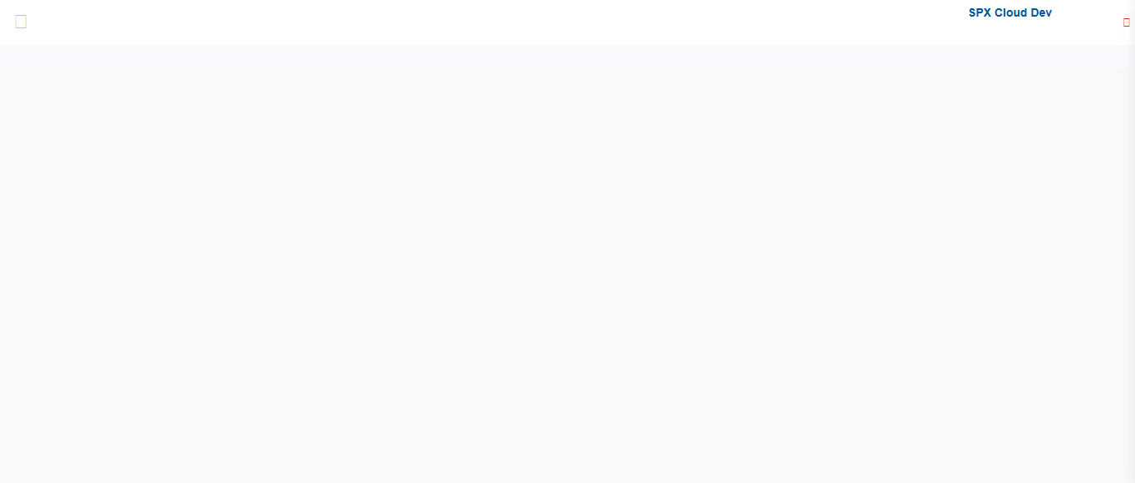Image file-name: QC_Testing-runTestMultipleTimes-nov. 20 2025, 02 39 51 p. m.

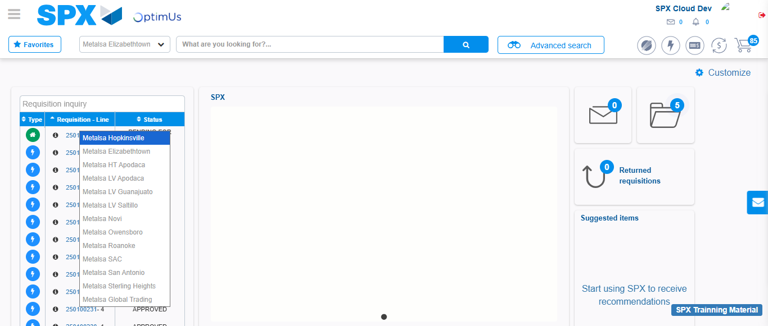Image file-name: QC_Testing-runTestMultipleTimes-nov. 20 2025, 02 39 52 p. m.

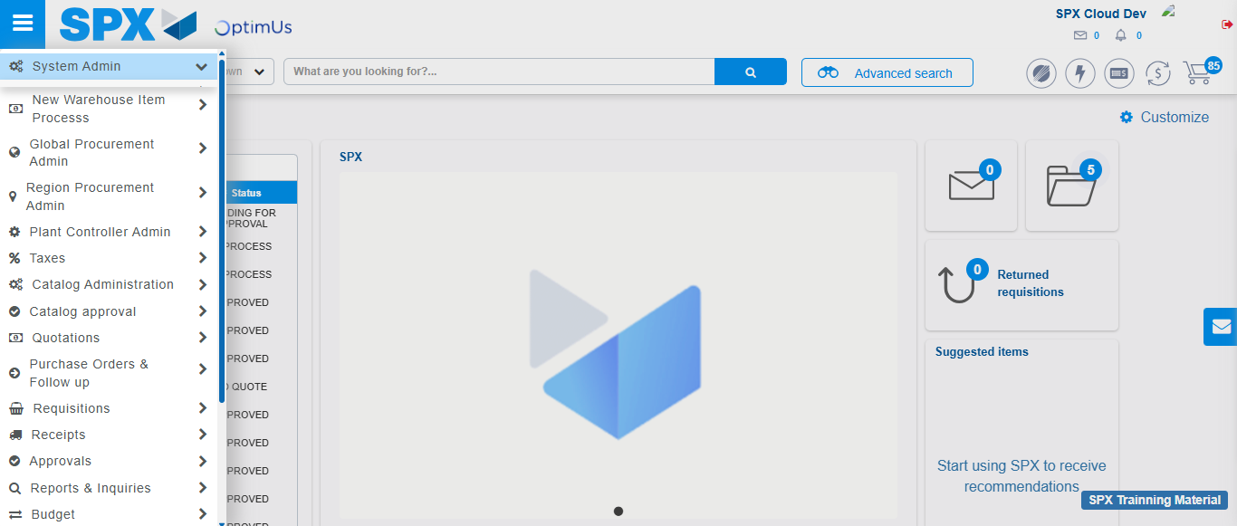Image file-name: QC_Testing-runTestMultipleTimes-nov. 20 2025, 02 39 53 p. m.

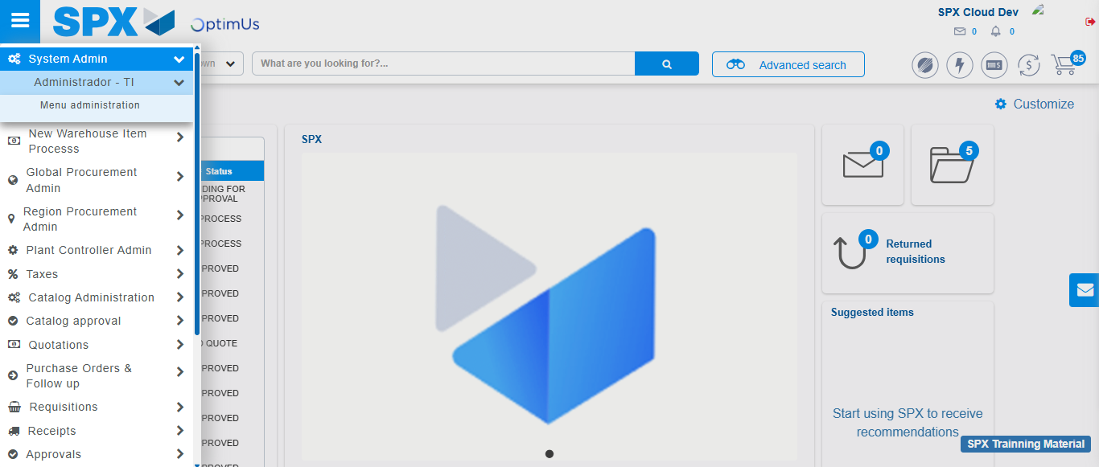Image file-name: QC_Testing-runTestMultipleTimes-nov. 20 2025, 02 39 54 p. m.

Image file-name: QC_Testing-runTestMultipleTimes-nov. 20 2025, 02 39 57 p. m.

Image file-name: QC_Testing-tc001_SPX_Dev5_Validar_Filtro_Campo_MenuName_Administrador_Roles_Menu-nov. 20 2025, 02 40 13 p. m.

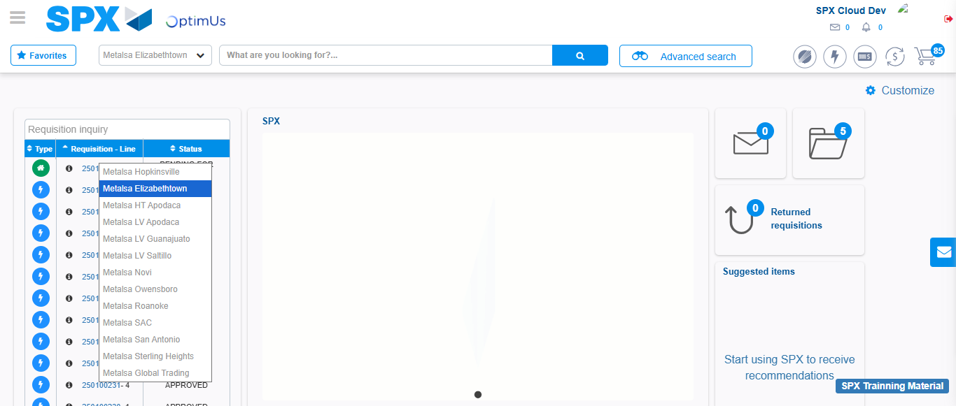Image file-name: QC_Testing-tc001_SPX_Dev5_Validar_Filtro_Campo_MenuName_Administrador_Roles_Menu-nov. 20 2025, 02 40 14 p. m.

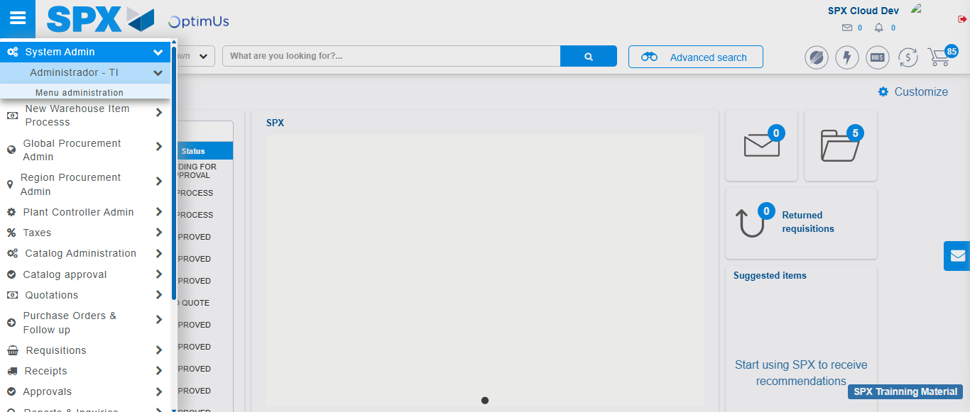Image file-name: QC_Testing-tc001_SPX_Dev5_Validar_Filtro_Campo_MenuName_Administrador_Roles_Menu-nov. 20 2025, 02 40 15 p. m.

Image file-name: QC_Testing-tc001_SPX_Dev5_Validar_Filtro_Campo_MenuName_Administrador_Roles_Menu-nov. 20 2025, 02 40 17 p. m.

Image file-name: QC_Testing-tc002_SPX_Dev5_Validar_Filtro_Campo_URLPath_Administrador_Roles_Menu-nov. 20 2025, 02 40 36 p. m.

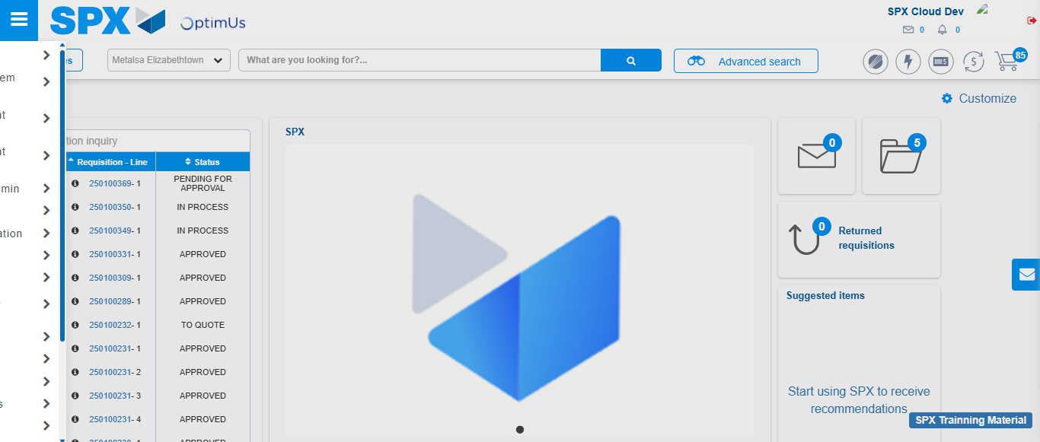Image file-name: QC_Testing-tc002_SPX_Dev5_Validar_Filtro_Campo_URLPath_Administrador_Roles_Menu-nov. 20 2025, 02 40 37 p. m.

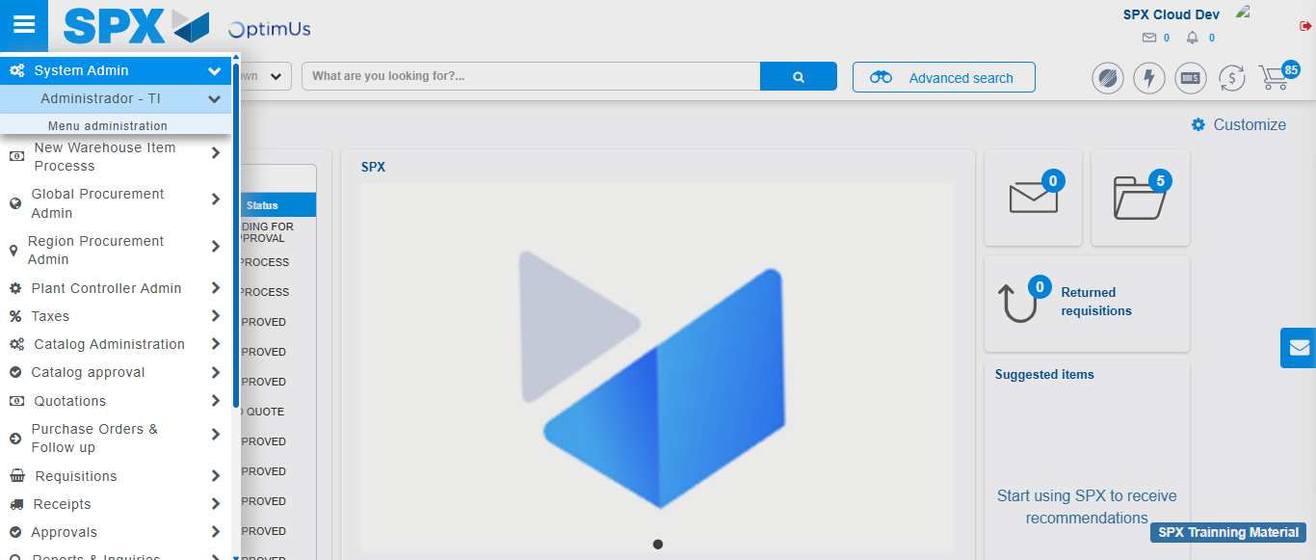Image file-name: QC_Testing-tc002_SPX_Dev5_Validar_Filtro_Campo_URLPath_Administrador_Roles_Menu-nov. 20 2025, 02 40 38 p. m.

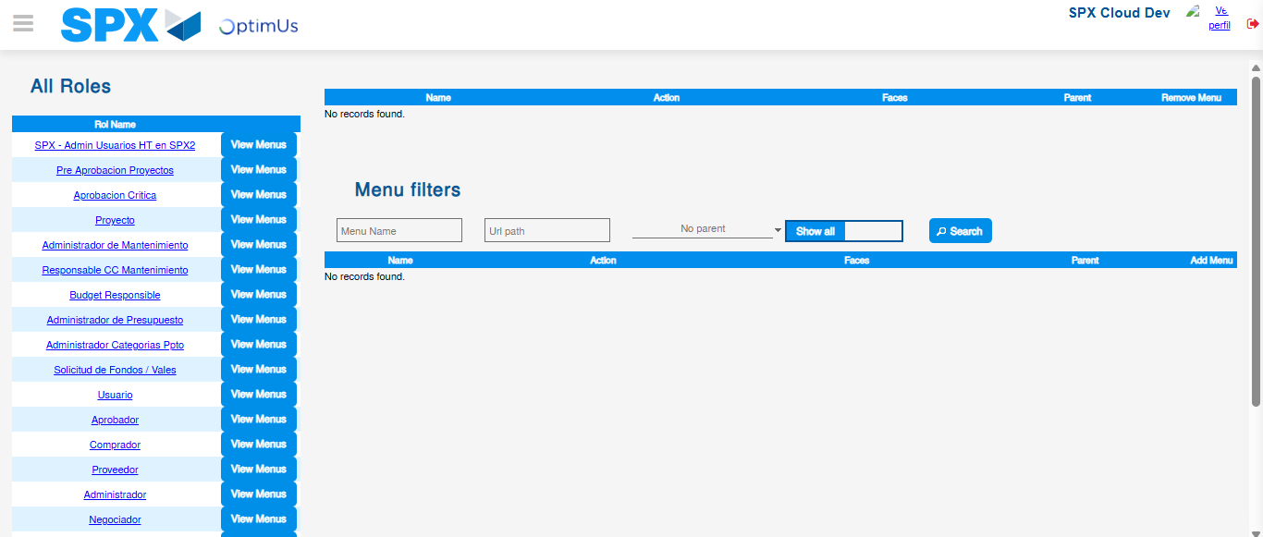Image file-name: QC_Testing-tc002_SPX_Dev5_Validar_Filtro_Campo_URLPath_Administrador_Roles_Menu-nov. 20 2025, 02 40 40 p. m.

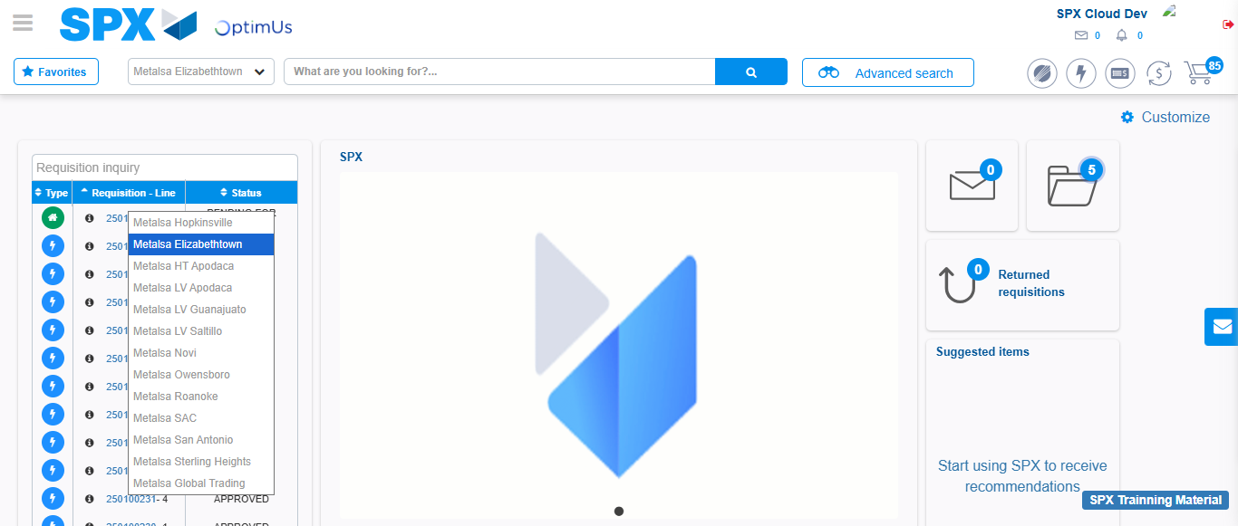Image file-name: QC_Testing-tc003_SPX_Dev5_Validar_Funcionalidad_Botones_Add_Remove_Administrador_Roles_Menu-nov. 20 2025, 02 41 02 p. m.

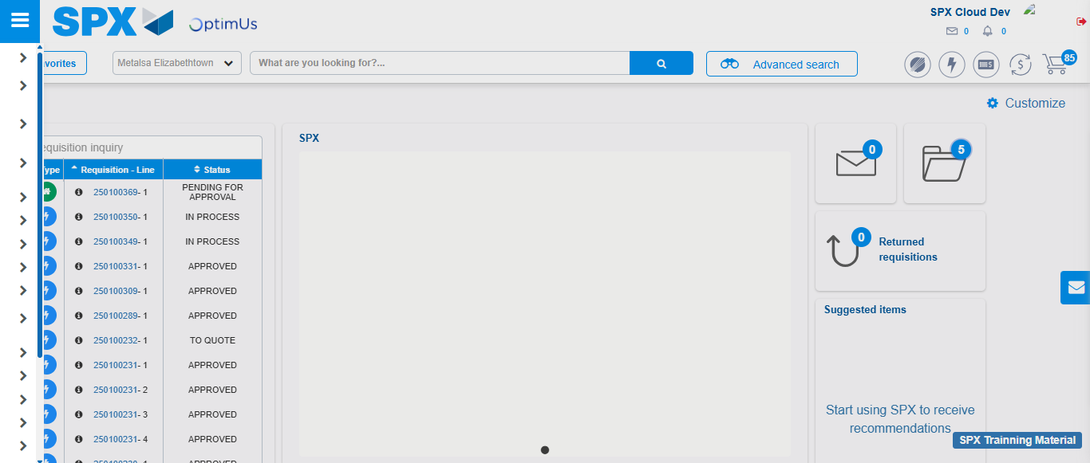Image file-name: QC_Testing-tc003_SPX_Dev5_Validar_Funcionalidad_Botones_Add_Remove_Administrador_Roles_Menu-nov. 20 2025, 02 41 03 p. m.

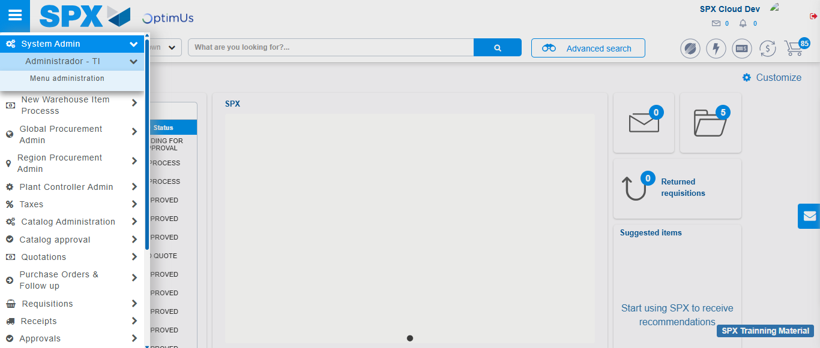Image file-name: QC_Testing-tc003_SPX_Dev5_Validar_Funcionalidad_Botones_Add_Remove_Administrador_Roles_Menu-nov. 20 2025, 02 41 04 p. m.

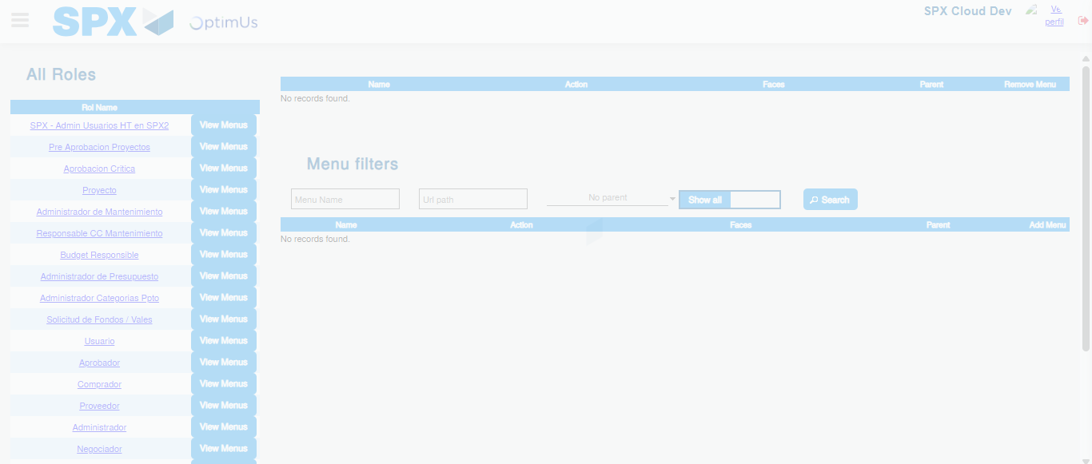Image file-name: QC_Testing-tc003_SPX_Dev5_Validar_Funcionalidad_Botones_Add_Remove_Administrador_Roles_Menu-nov. 20 2025, 02 41 06 p. m.

Step 3 - Click to Buttons View Menu and Search Filter with Menu Name and Add new record and Delete Record: Correct Search and Record successfully added and Record successfully deleted
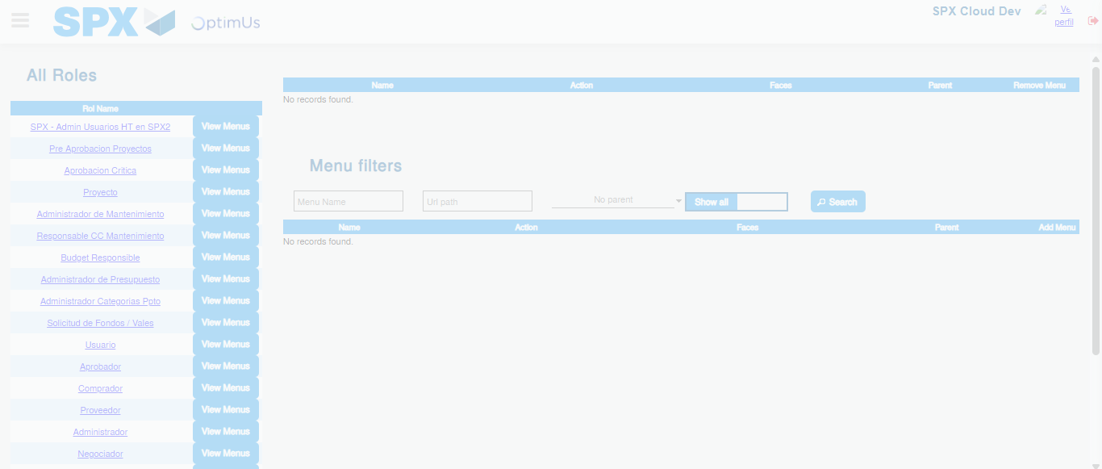Image file-name: QC_Testing-runTestMultipleTimes-nov. 20 2025, 02 39 58 p. m.

Image file-name: QC_Testing-tc001_SPX_Dev5_Validar_Filtro_Campo_MenuName_Administrador_Roles_Menu-nov. 20 2025, 02 40 17 p. m.

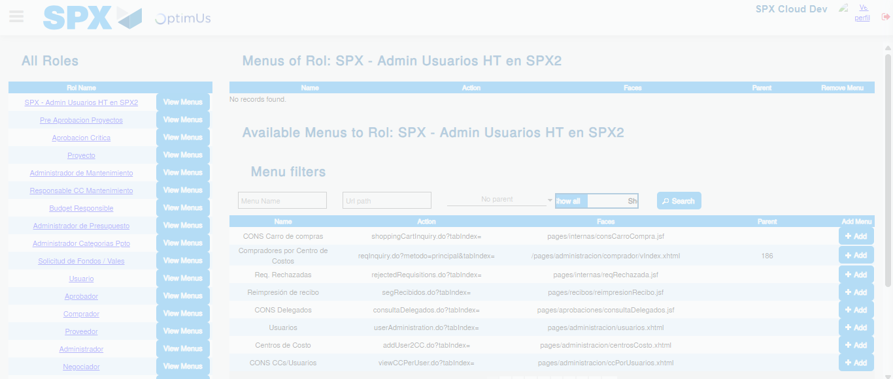Image file-name: QC_Testing-tc001_SPX_Dev5_Validar_Filtro_Campo_MenuName_Administrador_Roles_Menu-nov. 20 2025, 02 40 18 p. m.

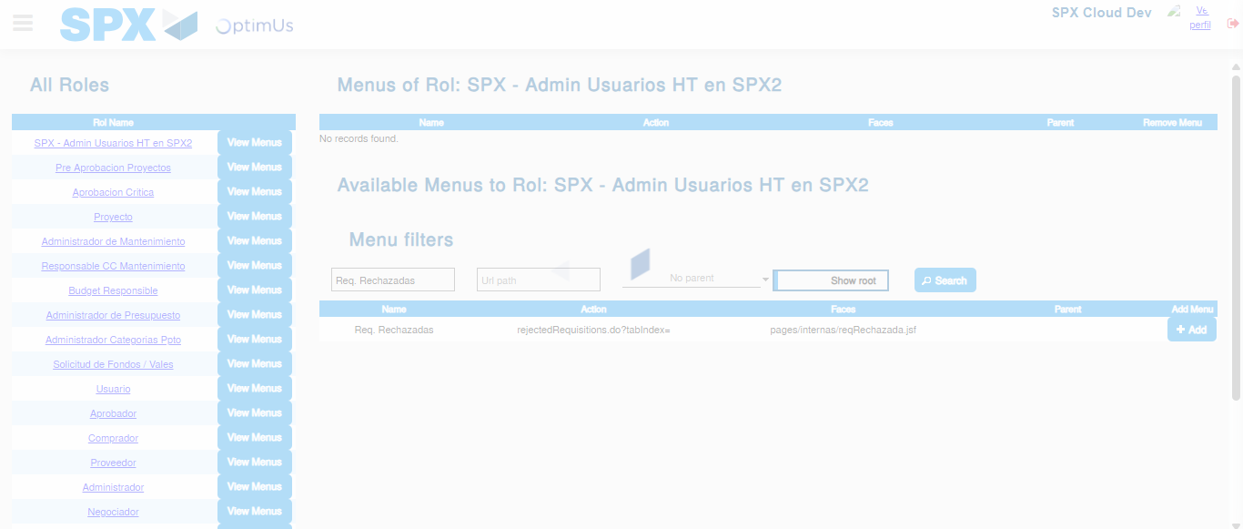Image file-name: QC_Testing-tc001_SPX_Dev5_Validar_Filtro_Campo_MenuName_Administrador_Roles_Menu-nov. 20 2025, 02 40 19 p. m.

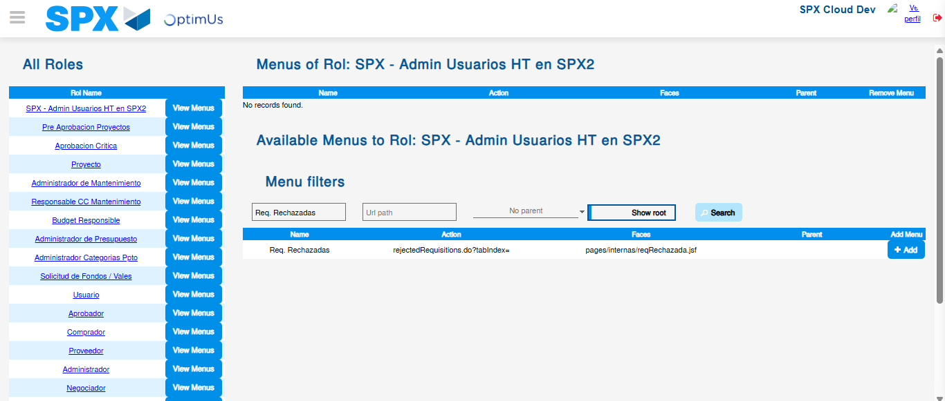Image file-name: QC_Testing-tc001_SPX_Dev5_Validar_Filtro_Campo_MenuName_Administrador_Roles_Menu-nov. 20 2025, 02 40 20 p. m.

Image file-name: QC_Testing-tc002_SPX_Dev5_Validar_Filtro_Campo_URLPath_Administrador_Roles_Menu-nov. 20 2025, 02 40 40 p. m.

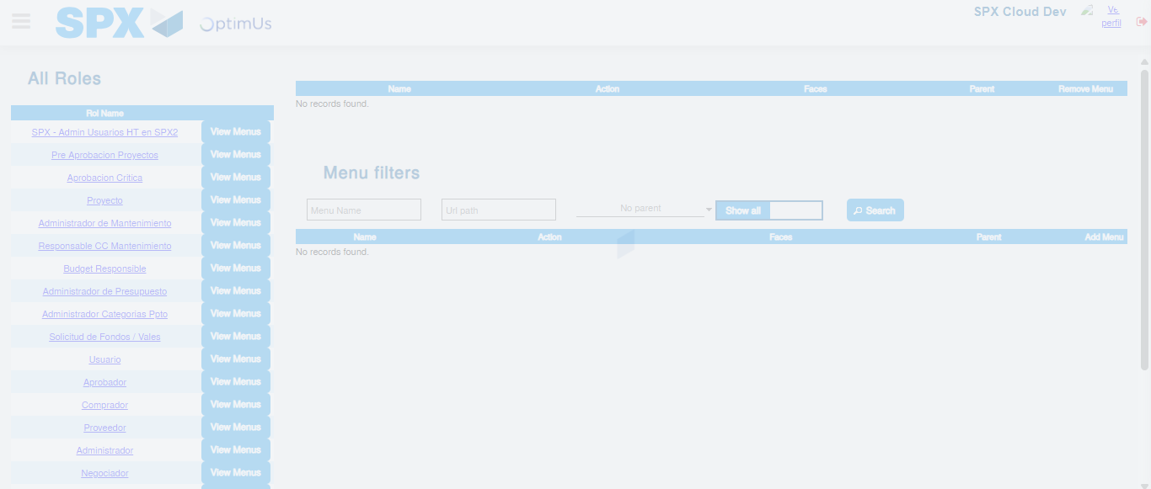Image file-name: QC_Testing-tc002_SPX_Dev5_Validar_Filtro_Campo_URLPath_Administrador_Roles_Menu-nov. 20 2025, 02 40 41 p. m.

Image file-name: QC_Testing-tc003_SPX_Dev5_Validar_Funcionalidad_Botones_Add_Remove_Administrador_Roles_Menu-nov. 20 2025, 02 41 06 p. m.

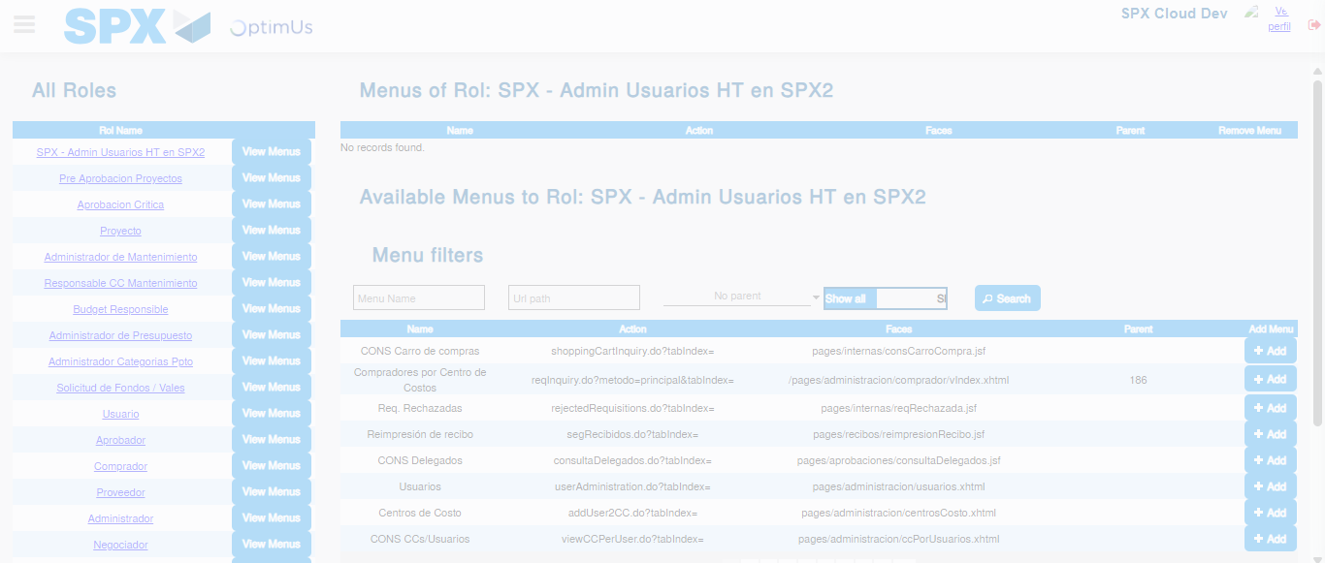Image file-name: QC_Testing-tc003_SPX_Dev5_Validar_Funcionalidad_Botones_Add_Remove_Administrador_Roles_Menu-nov. 20 2025, 02 41 07 p. m.

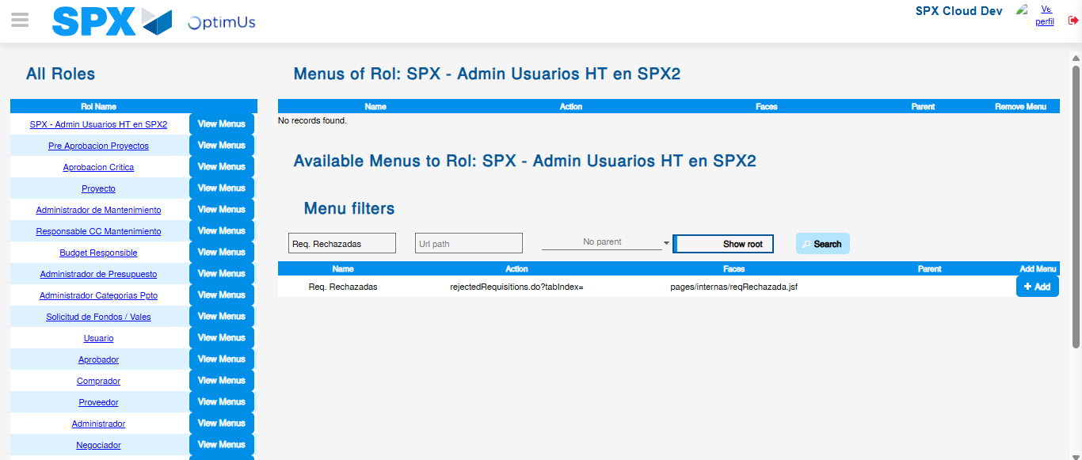Image file-name: QC_Testing-tc003_SPX_Dev5_Validar_Funcionalidad_Botones_Add_Remove_Administrador_Roles_Menu-nov. 20 2025, 02 41 08 p. m.

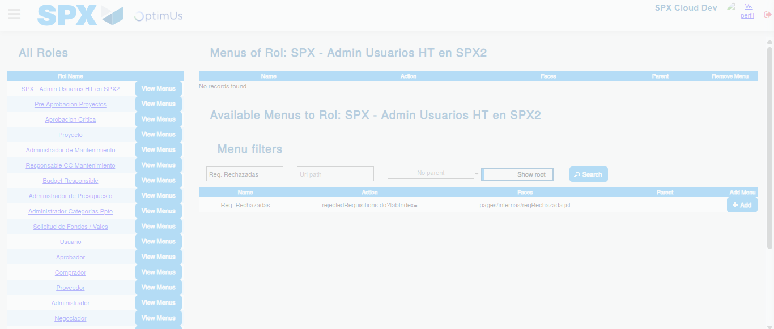Image file-name: QC_Testing-tc003_SPX_Dev5_Validar_Funcionalidad_Botones_Add_Remove_Administrador_Roles_Menu-nov. 20 2025, 02 41 09 p. m.

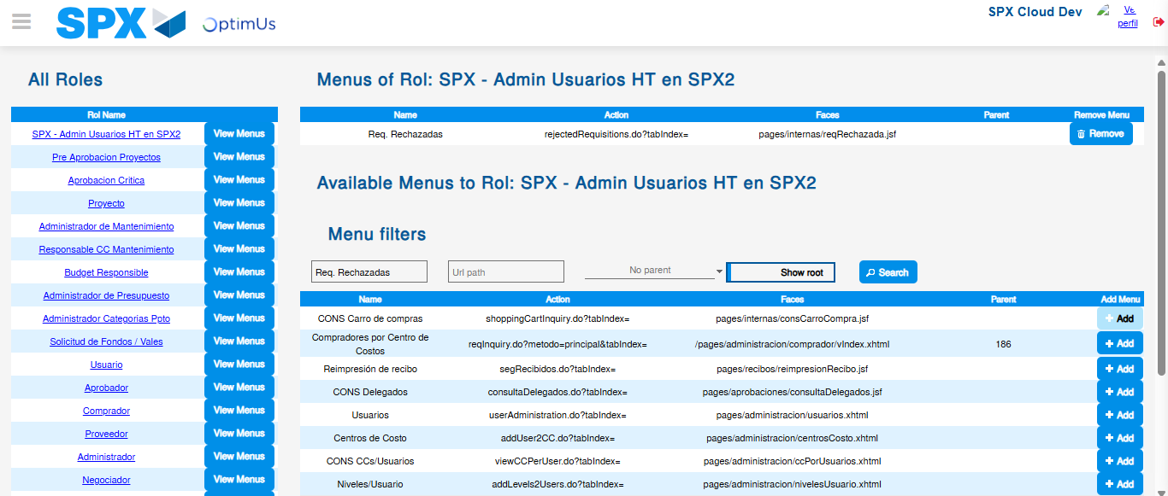Image file-name: QC_Testing-tc003_SPX_Dev5_Validar_Funcionalidad_Botones_Add_Remove_Administrador_Roles_Menu-nov. 20 2025, 02 41 12 p. m.

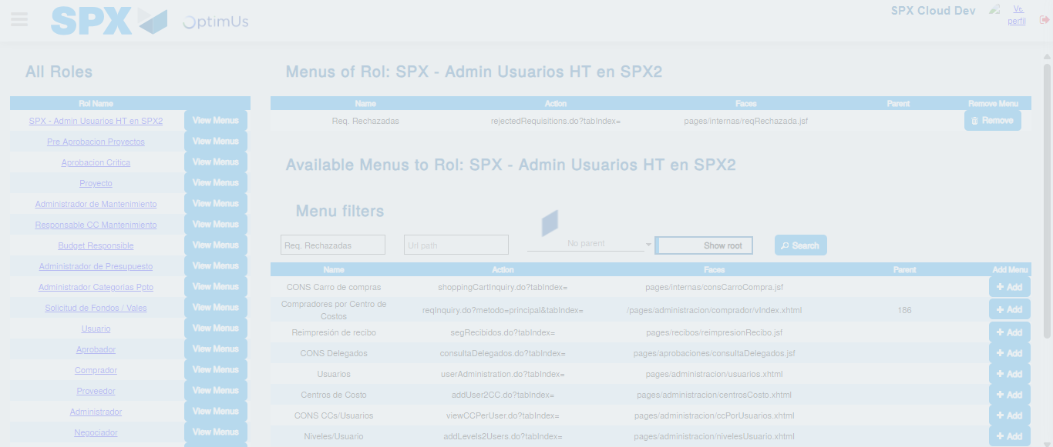Image file-name: QC_Testing-tc003_SPX_Dev5_Validar_Funcionalidad_Botones_Add_Remove_Administrador_Roles_Menu-nov. 20 2025, 02 41 13 p. m.

